Migrating servers from Azure: Part 1
Creating server Image in Azure (Windows server migration )
Prerequisites
- VM Import/Export supports OVA, VMDK, and VHD/VHDX file formats to be imported in AWS.
- Boot modes supported are Unified Extensible Firmware Interface (UEFI) and Legacy BIOS.
Below is a demonstration of how we can implement the process of migrating the servers from Azure to AWS.
Take a snapshot of the VM Disk
In the Azure portal, Go to the disk of the virtual machine which you are going to migrate. Take a snapshot and click on the Generate URLs to generate a SAS token and set the expiration time in seconds as shown below.
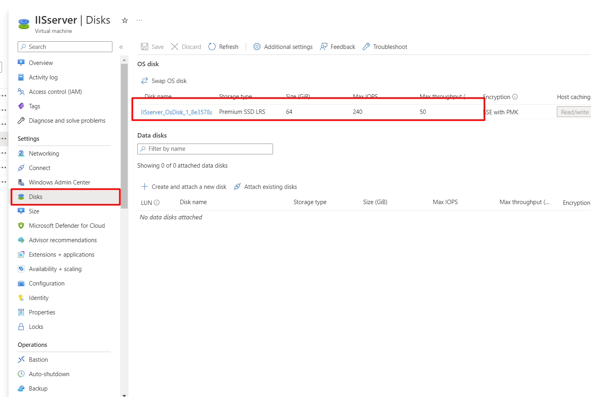Virtual Machine Desk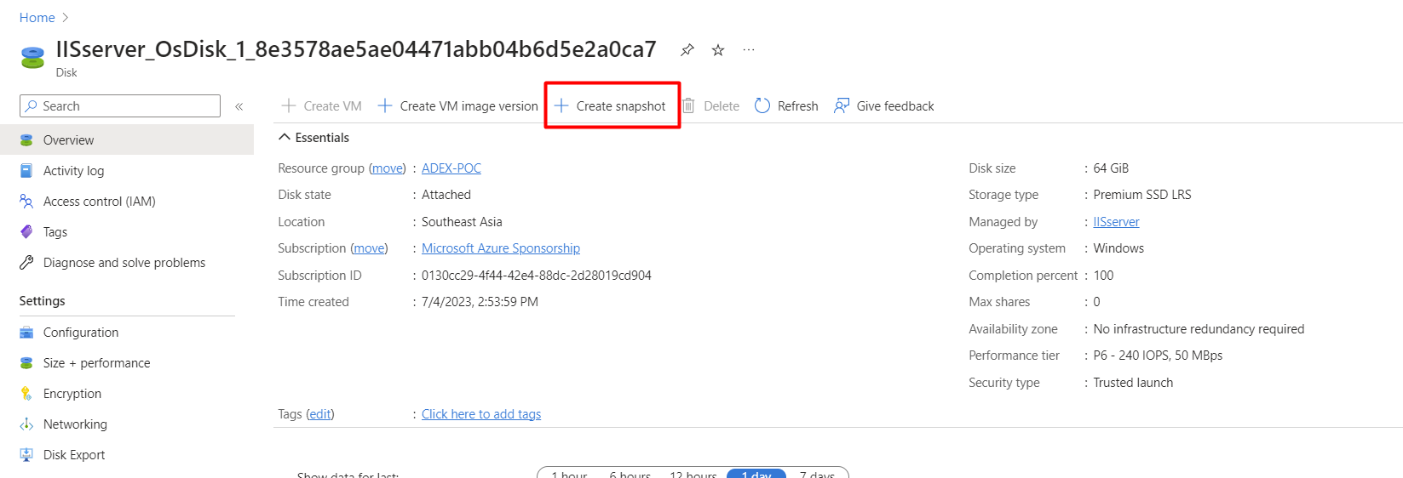Snapshot Creation
After creating the snapshot, export the image as shown in the figure .
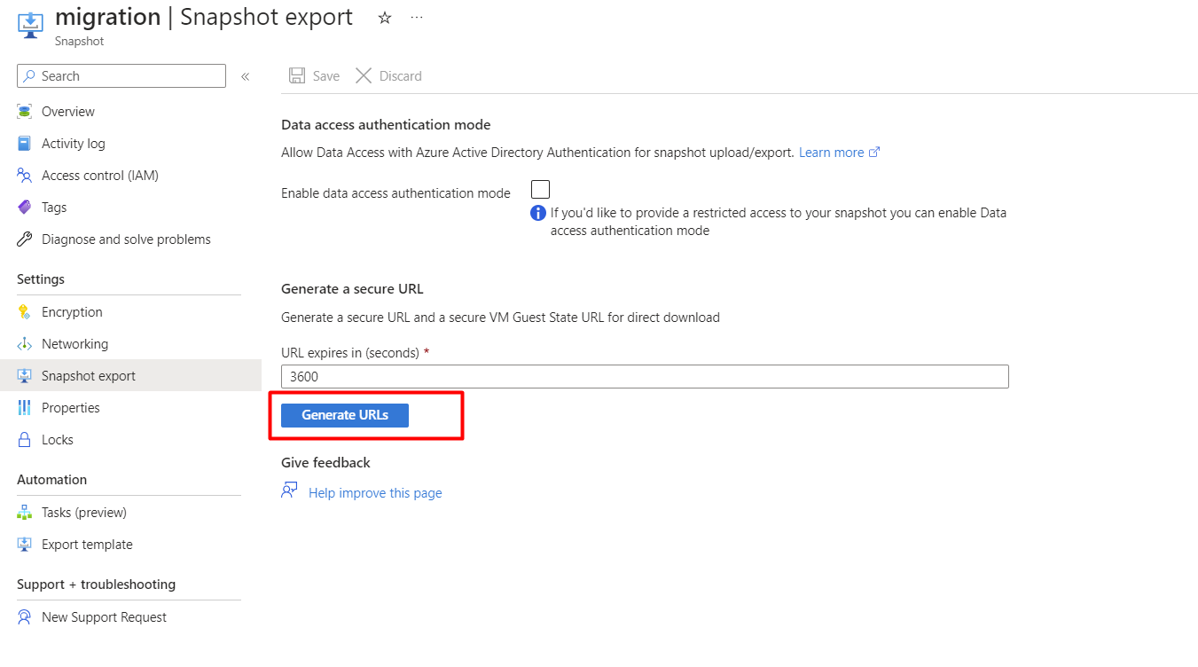Generate URLs
Copy the generated URL and browse the URL in your machine so that it downloads the disk to export it to AWS.
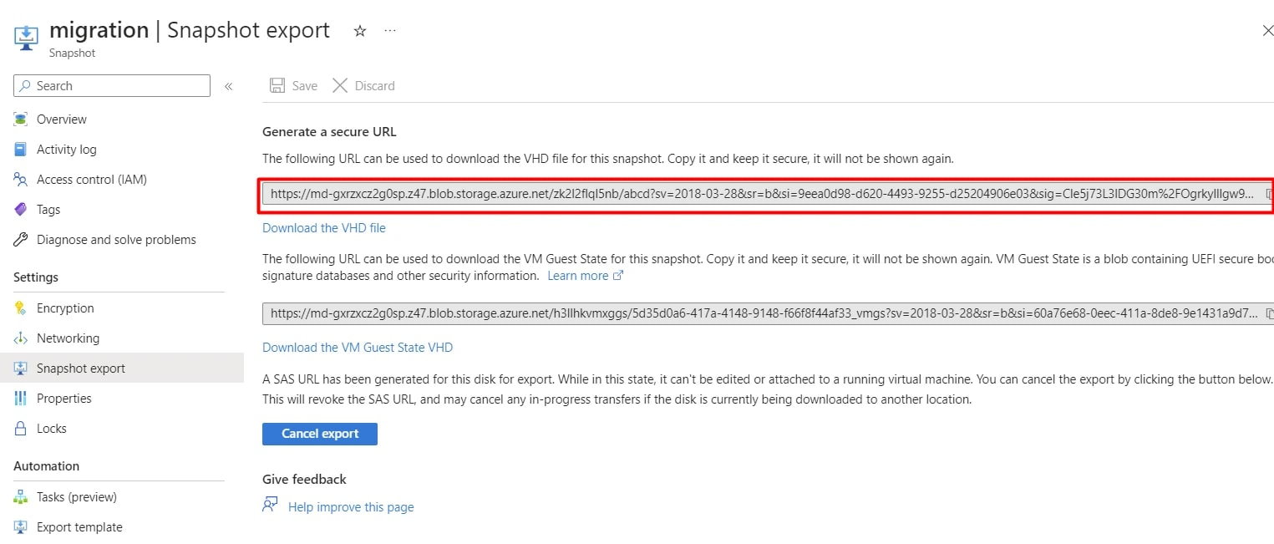SAS token generation
Another approach could be to stop the instance, and export the disk following the above mentioned process. Also, we could take snapshots of the instances without stopping it in the previous explained method.
Disk Selection
Go to disk for exporting the VHD file as we did in the above steps.
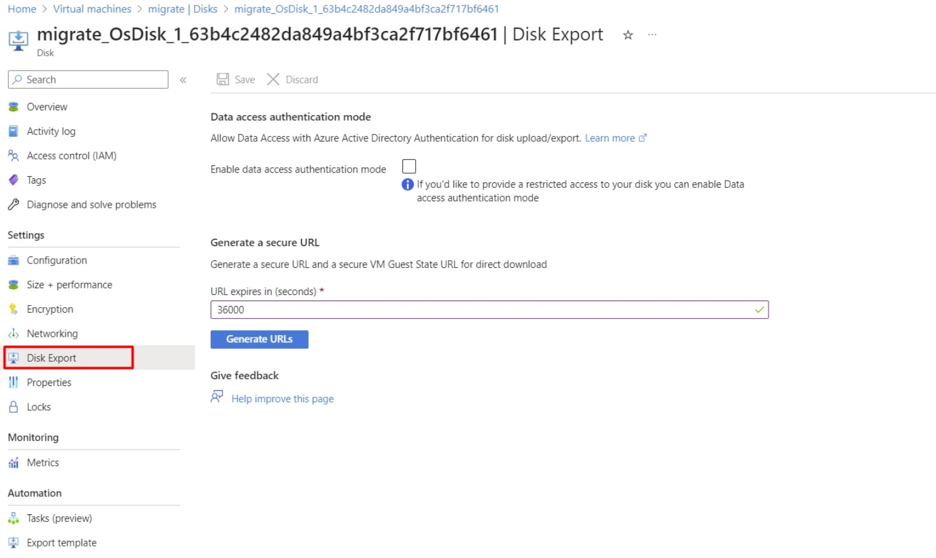Generate URL
Click on the disk export and a SAS token will be generated and the disk can be downloaded using the provided URL.
Direct uploading the VHD file to the S3 bucket using the following command by creating an ec2 instance of C5, and M5 as they have large network throughput.
curl "https://download-link-address/" | aws s3 cp - s3://aws-bucket/data-file

After the process of downloading the virtual machine image, upload the file to S3 bucket. Multipart upload can be implemented if the file size is too large.
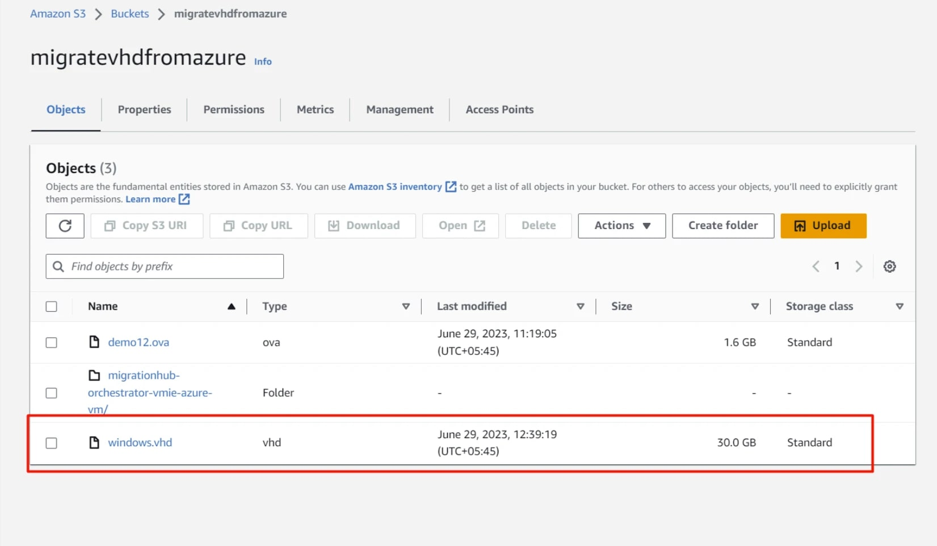
We have now successfully created the image from Azure and uploaded it to AWS S3.
Now, we look at the second part where we create an image from the on-prem environment.
Migrating servers from On-prem: Part-2
Creating Virtual Machine Images from On-prem (Virtual Box)
In migrating from on-prem to AWS, we will use a virtual box image of Ubuntu 22.04. The virtual image file will be in the format OVA, as AWS supports file type OVA, VMDX, and VHD.
Generate the OVA file
We will generate the OVA file from the virtual box Ubuntu 22.04 Server, and export the Virtual Machine image file from the Virtual Box. After generating the OVA file as shown below with 1.6GB in size.
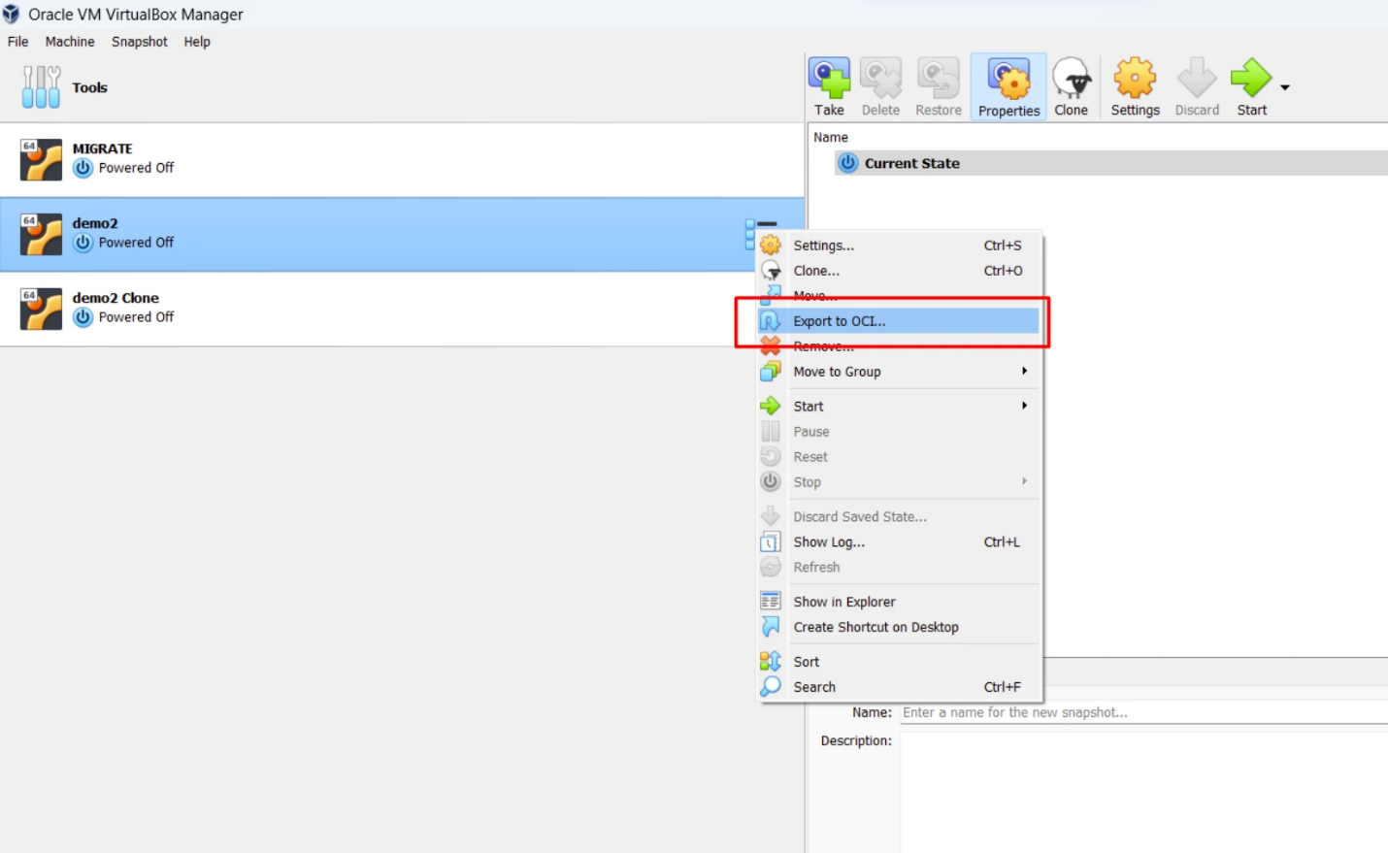VM export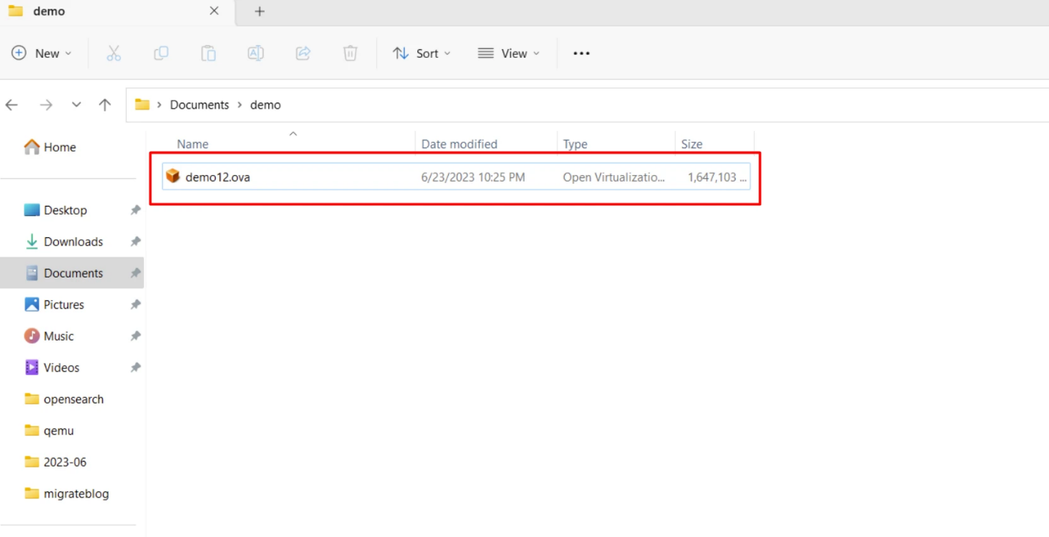OVA file from VirtualBox
Upload the OVA file to the S3 bucket
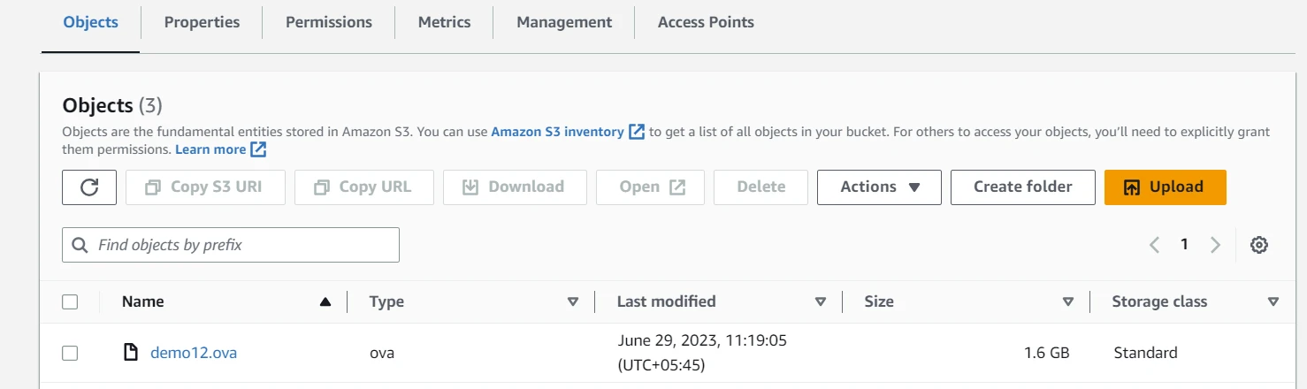S3 Bucket containing OVA file
We have now successfully created the image from on prem environment and uploaded it to AWS S3. Now, we look at how we can create instances from the uploaded images.
Creating instances from the Images
By following above steps, we will be able to download VHD file from Azure, as well as from the on-prem environment and upload it to S3 bucket.
The next step now would be to create instances from the images.
For the console-based migration, we can use Import virtual machine images to the AWS template in the Migration Hub Orchestrator console.
AWS VM Import/Export strongly recommends specifying a value for either the --license-type or --usage-operation parameter when you create a new VM Import task. This ensures your operating system is licensed appropriately and your billing is optimized.
We will be importing the VHD file from S3 that was created from the Azure virtual machine which is a Windows instance.
Open AWS CLI to import the file
Use your local machine where you have configured AWS CLI. Create an import.json file that describes the OVA file and the bucket names as shown below.
[

{

"Description": "VHD import",

"Format": "VHD",

"Url": "s3://S3BUCKETNAME/FILENAME"

}

]
Replace the name of the Bucket with your bucket name .
Now, use the command
migrate="ubuntumigrate"

aws ec2 import-image --description $migrate --disk-containers "file://import.json"
file:// points to the location of the saved import.json file. The --description defines the definition of the import task.
If you are not authorized to perform this action
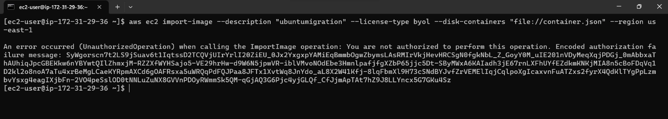
Create an IAM role named "vmimport" with the trust policy trust-policy.json that allows the VM import service to assume the role.
{
"Version": "2012-10-17",
"Statement": [
{
"Effect": "Allow",
"Principal": {
"Service": "vmie.amazonaws.com"
},
"Action": "sts:AssumeRole",
"Condition": {
"StringEquals": {
"sts:Externalid": "vmimport"
}
}
}
]
}
From the AWS CLI
aws iam create-role --role-name vmimport --assume-role-policy-document "file://trust-policy.json"
Attach the following IAM policy named "vmimport" to the IAM role to grant permissions with the file name role-policy.json
{
"Version": "2012-10-17",
"Statement": [
{
"Effect": "Allow",
"Action": [
"s3:GetBucketLocation",
"s3:GetObject",
"s3:ListBucket"
],
"Resource": [
"arn:aws:s3:::disk-image-file-bucket",
"arn:aws:s3:::disk-image-file-bucket/*"
]
},
{
"Effect": "Allow",
"Action": [
"ec2:ModifySnapshotAttribute",
"ec2:CopySnapshot",
"ec2:RegisterImage",
"ec2:Describe*"
],
"Resource": "*"
}
]
}
Note : Replace the bucket name with your bucket name
aws iam put-role-policy --role-name vmimport --policy-name vmimport --policy-document "file://role-policy.json"
Now, you will not get the error, run the import image task.
migrate="ubuntumigrate"
aws ec2 import-image --description $migrate --license-type byol --disk-containers "file://import.json"
We can view the import process using the command
aws ec2 describe-import-image-tasks
The process will take some time for the import, to check the status use
aws ec2 describe-import-image-tasks --import-task-ids ImportTaskId
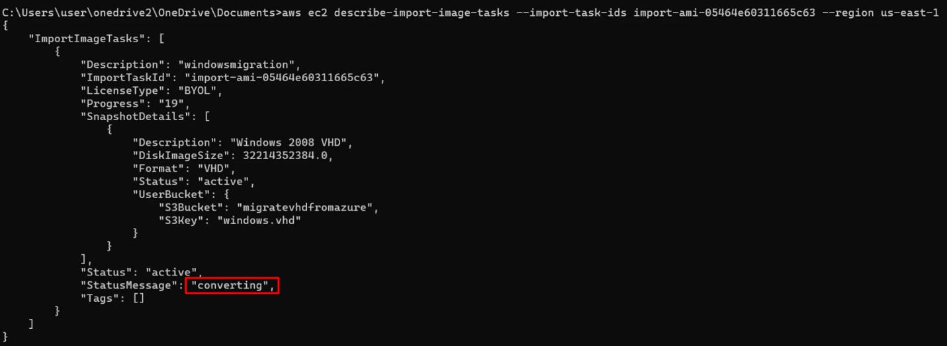Status showing converting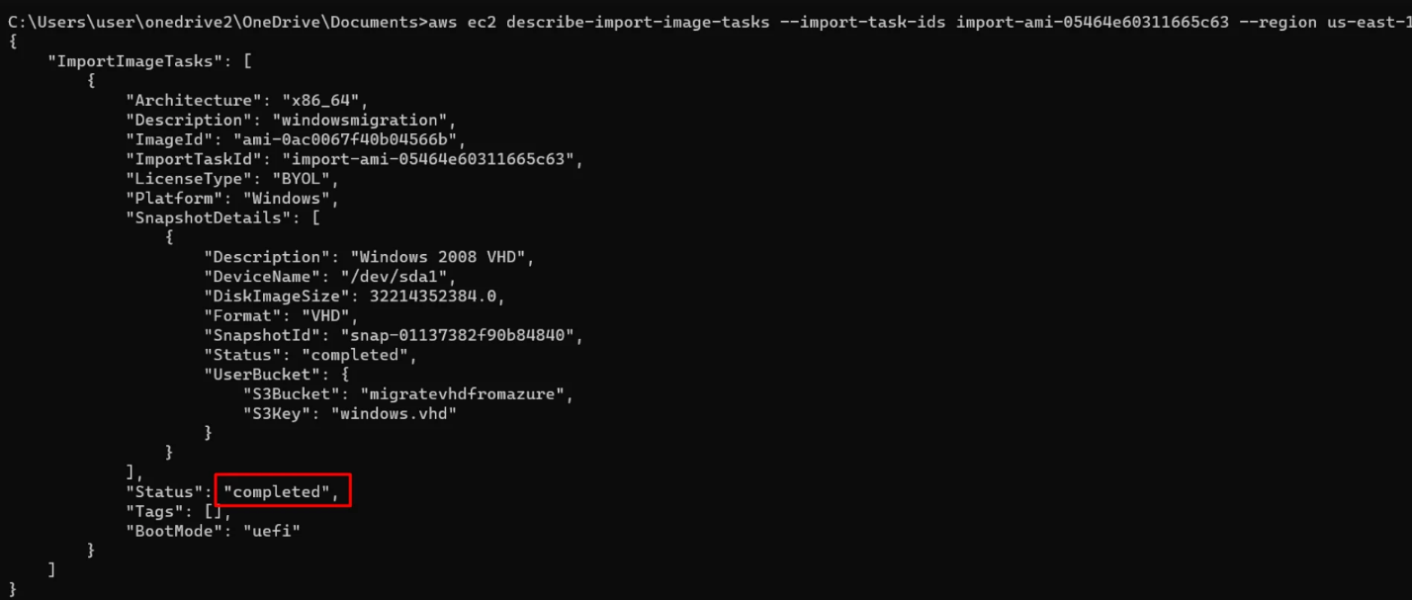Status to be completed
Once the import process is complete, verify the image after going to the AMI library.
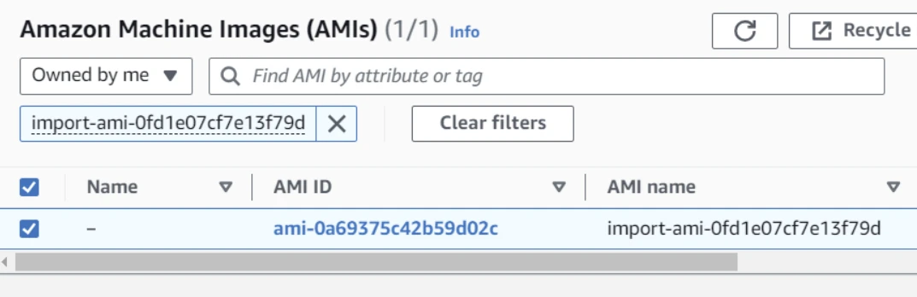
Outcome
By following the above procedures for migrating servers to AWS, we can find the below results by looking into the AWS console. Before migration, the server in Azure is a Windows server that is hosting a static site as we can see below with IP address 4.194.82.205
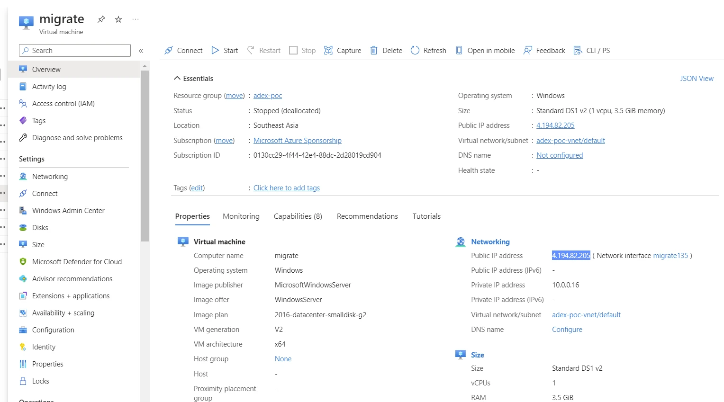Virtual Machine in Azure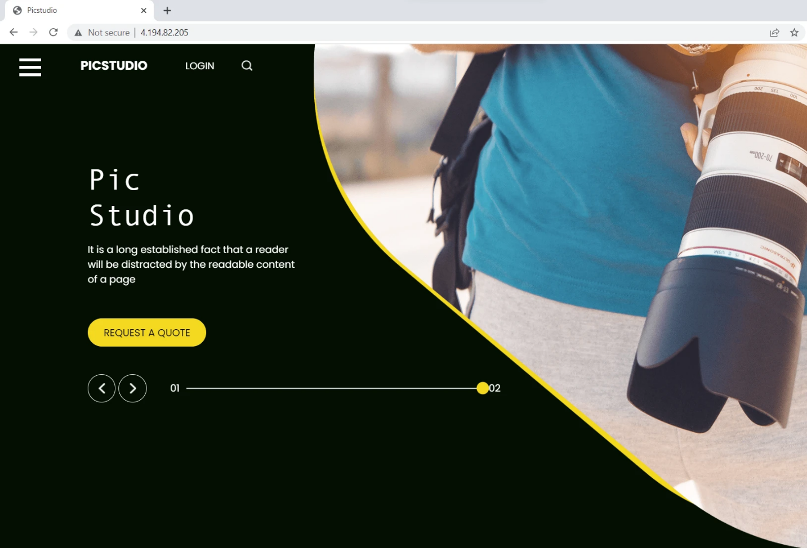Site hosted on the Azure server
After migration, here are the details of the server in AWS with IP address 54.197.73.202 with Windows instance and instance type t3.micro
